

Artificial Intelligence



Home Automation with Voice agent

January 02/01/2025

Obaidullah | 221109

Moiz | 221073

Ali Afzal | 220827

Submitted to

Maam Fariyal Farooq

**Contents**

1. ABSTRACT 2

2. INTRODUCTION 2

3.OBJECTIVES 2

4.Agent-Based Architecture 3

5. Natural Language Processing (NLP) 3

6.Speech Recognition (ASR) 4

7. Large Language Models (LLMs) 4

8. Function Calling / Tool Use 5

9. Intent Recognition & Classification 5

10. Reactive Agents 6

11. Perception–Action Loop 6

12. Context-Aware Computing 6

13. Multi-Modal AI 7

14 AI-Centric Summary 7

14.COMPONENTS USED 8

UI Design : 9

15.CIRCUIT DIAGRAM 9

16.SYSTEM WORKING (MODULE-WISE EXPLANATION) 10

Module 1: LDR and Night LED 10

Module 2: Garage Door Automation 11

Module 3: Motion Detection and Security Alert 11

Module 4: Rain Water Detection and Clothes Protection 12

Module 5: Soil Moisture and Water Tank Monitoring 13

Module 6: Fire and Smoke Detection 15

Module 7: Temperature and Humidity Monitoring 17

17.ARDUINO CODE 18

Components: 24

Protocols : 27

18.CONCLUSION 30

# ABSTRACT

This IoT-based project, Smart Home and Agriculture System, automates and monitors both household and agricultural environments using an Arduino Uno R3 microcontroller. It integrates a wide range of sensors and actuators to handle smart lighting, garage door automation, intruder detection, automatic clothes covering during rain, soil-based irrigation control, fire and smoke alarms, and environmental monitoring (temperature & humidity). The system improves convenience, safety, and environmental sustainability through real-time automation.

# INTRODUCTION

In recent years, the integration of Internet of Things (IoT) technologies into daily life has transformed traditional systems into smart, automated, and efficient solutions. Smart homes offer convenience, security, and energy efficiency by automating lighting, doors, and monitoring systems. Similarly, modern agriculture benefits from automated irrigation, environmental monitoring, and early warning systems.

This project — Smart Home and Agriculture System — merges both domains using an Arduino Uno and a collection of sensors and actuators. The system responds to environmental data (light, moisture, temperature, rain, motion, etc.) in real-time to trigger appropriate actions. These include turning lights on at night, covering clothes when it rains, opening a garage door, detecting intrusions, watering dry soil, and alerting in case of fire or smoke.

The project is low-cost, modular, and expandable, making it suitable for both home automation and smart farming applications. It demonstrates the power of embedded systems, sensor networks, and real-world automation using Arduino and simple electronics.

# 3.OBJECTIVES

* + Automate daily home and farm tasks
  + Improve resource usage (electricity, water)
  + Enhance safety using sensors for fire, gas, and intruders
  + Provide hands-free environmental monitoring
  + Demonstrate practical IoT integration using Arduino

# 4.Agent-Based Architecture

In Artificial Intelligence, an agent is an autonomous computational entity that continuously perceives its environment through sensors, reasons using internal models, and acts using actuators to achieve predefined or learned goals.

**AI Role in This System**

The IoT Smart Home operates as a Hybrid Intelligent Agent System, integrating:

**Reactive AI (rule-based automation)**

**Cognitive AI (LLM-based reasoning)**

This hybrid design ensures both real-time responsiveness and high-level intelligence.

**AI Mapping**

|  |  |
| --- | --- |
| **AI Stage** | **Implementation** |
| Perception | Sensors (temperature, motion, light, gas) |
| Reasoning | LLM + rule engine |
| Action | Smart devices (lights, AC, alarms) |

**Agent Properties (AI-Aligned)**

|  |  |
| --- | --- |
| **Property** | **AI Interpretation** |
| Autonomy | Decisions without human intervention |
| Reactivity | Immediate response to sensor events |
| Proactiveness | Predictive and preventive actions |
| Social Ability | Human interaction via natural language |

**AISignificance:**  
This architecture aligns with Russell & Norvig’s Intelligent Agent Model.

# 5. Natural Language Processing (NLP)

NLP enables machines to understand, interpret, and reason over human language using statistical and neural models.

**NLP Functions in the System**

* Tokenization & semantic parsing
* Intent detection
* Entity recognition (device, location, action)

**AI Example**

**User Input:**

“Turn on the living room lights”

**AI Output:**

{

"intent": "CONTROL_DEVICE",

"device": "light",

"location": "living_room",

"action": "on"

}

**AI Advantage**

Handles synonyms and paraphrasing

Reduces dependency on rigid command structures

Supports conversational interaction

# 6.Speech Recognition (ASR)

ASR is a deep learning-based supervised learning task that converts acoustic signals into textual representations.

**Model Used**

OpenAI Whisper (**Transformer-based ASR**)

**AI Pipeline:**

Audio Signal → Spectrogram → Neural Network → Text Output

**AI Importance**

* Enables hands-free control
* Improves accessibility
* Bridges human speech with machine cognition

# 7. Large Language Models (LLMs)

LLMs are transformer-based foundation models trained on large-scale textual data to perform reasoning, planning, and language understanding.

**AI Role in the System**

* Acts as the cognitive brain
* Resolves ambiguous commands
* Maintains conversational context
* Translates human intent into machine actions

**Why LLMs Are AI-Critical**

|  |  |
| --- | --- |
| Capability | AI Benefit |
| Reasoning | Goal-oriented decisions |
| Context | Memory across interactions |
| Generalization | Handles unseen instructions |
| Adaptability | Learns user preferences |
|  |  |

# 8. Function Calling / Tool Use

Function calling enables tool-augmented intelligence, where AI outputs are converted into executable system commands.

**AI Flow**

Natural Language → LLM Reasoning → Structured JSON → Backend Function → Actuator

Example

{

"function": "switch_device",

"parameters": {

"device": "AC",

"state": "ON"

}

}

**AI Benefit**

Connects abstract reasoning to physical actions

Ensures safe and deterministic execution

# 9. Intent Recognition & Classification

Intent recognition is a multi-class classification problem in NLP that maps user input to system goals.

**Intent Categories**

* Control Intent (device operation)
* Informational Intent (status queries)
* Emergency Intent (fire, gas leakage)

**AI Strength**

* Supports compound and nested intents
* Improves scalability of interaction design

# 10. Reactive Agents

Reactive agents operate using if–then rules, responding directly to stimuli without long-term planning.

**Role in Hybrid AI**

* Fire alarm activation
* Motion-based lighting
* Gas leakage alerts
* AI Justification

**Reactive AI is:**

* Fast
* Reliable
* Safety-critical
* Used where response time > reasoning complexity.

# 11. Perception–Action Loop

A fundamental AI loop connecting sensory input to intelligent action.

**Loop**

Perceive → Interpret → Decide → Act → Feedback

**AI Benefit**

* Continuous system operation
* Enables future learning integration
* Aligns with reinforcement learning frameworks

# 12. Context-Aware Computing

Context-aware AI adapts decisions using environmental, temporal, and user-specific data.

**Context Dimensions**

* Time (day/night)
* Location
* User habits
* Environmental state

**AI Example**

“Make it comfortable”

AI infers:

Temperature

Humidity

Timeof day  
→ Adjusts AC and fan automatically

# 13. Multi-Modal AI

Multi-modal AI combines multiple data types into a unified reasoning framework.

**Modalities Used**

* Audio (speech)
* Text (commands)
* Sensor data (IoT telemetry)

**AI Advantage**

* Improved accuracy
* Better situational awareness
* Human-like perception

# 14 AI-Centric Summary

|  |  |
| --- | --- |
| AI Domain | Application |
| Intelligent Agents | Autonomous control |
| NLP | Human-friendly commands |
| ASR | Voice interaction |
| LLMs | Cognitive intelligence |
| Tool Use | Action execution |
| Reactive AI | Safety automation |
| Context Awareness | Adaptive behavior |
| Multi-Modal AI | Robust perception |

# 14.COMPONENTS USED

|  |  |  |  |
| --- | --- | --- | --- |
| **No.** | **Component** | **Quantity** | **Function** |
| 1 | Arduino Uno R3 | 1 | Controls all components |
| 2 | HC-SR04 Ultrasonic Sensor | 2 | Garage door & water level detection |
| 3 | PIR Motion Sensor | 1 | Detects motion/intruders |
| 4 | Rain Sensor Module | 1 | Detects rainwater |
| 5 | LDR Sensor | 1 | Detects day/night lighting |
| 6 | IR Flame Sensor | 1 | Detects fire/flame |
| 7 | MQ2 Smoke Sensor | 1 | Detects smoke or gas leakage |
| 8 | Soil Moisture Sensor | 1 | Monitors soil dryness |
| 9 | SG90 Servo Motors | 2 | For garage door and clothes cover |
| 10 | IRFZ44N MOSFET | 1 | Controls pump switching |
| 11 | Water Pump | 1 | Waters soil when dry |
| 12 | DHT22 Sensor | 1 | Temperature & humidity monitoring |
| 13 | Buzzer | 1 | Alerts for motion/fire/smoke |
| 14 | LEDs | 2 | Use for Lighting and Indication |
| 15 | 10kΩ Resistors & Jumper Wires |  | For voltage division & connections |

# UI Design :

# 

# 15.CIRCUIT DIAGRAM

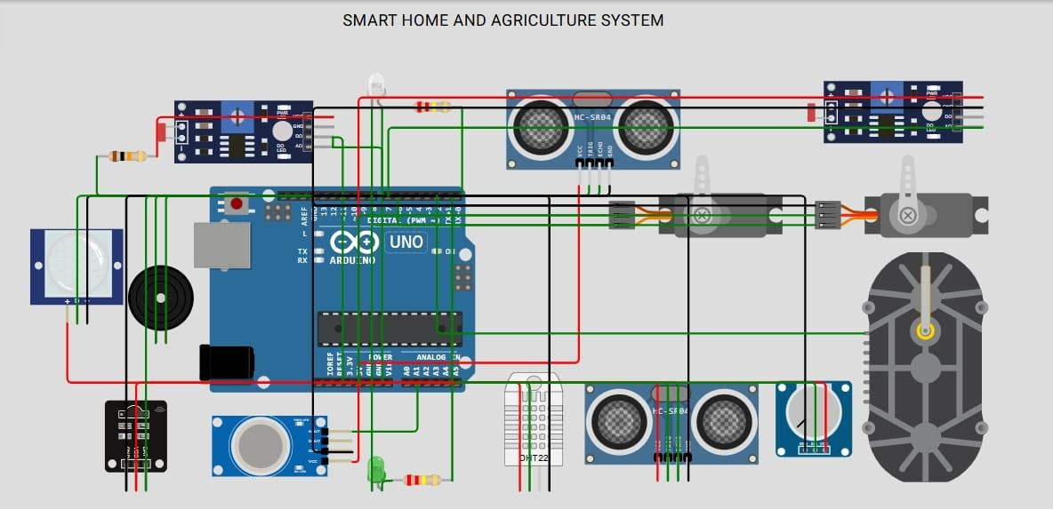

# 16.SYSTEM WORKING (MODULE-WISE EXPLANATION)

### Module 1: LDR and Night LED

**Component:** LDR Sensor

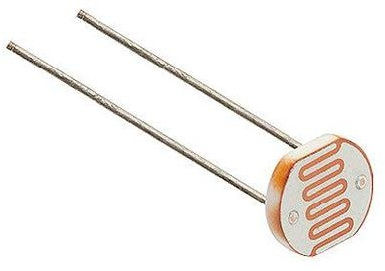

*Figure 1 LDR Sensor*

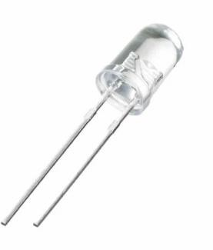

*Figure 2.White LED*

**Working:** This module uses a Light Dependent Resistor (LDR) to measure ambient light intensity. If the light level falls below a certain threshold (indicating darkness), an LED is automatically turned ON to illuminate the area. This simulates smart lighting that responds to time of day.

### Module 2: Garage Door Automation

Components: Ultrasonic Sensor, SG90 Servo Motor

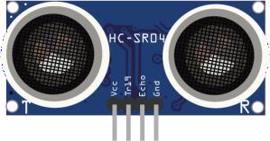

*Figure 3. HcSr04 Ultrasonic Sensor*

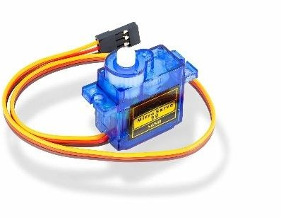

*Figure 4. Servo Motor SG-90*

**Working:** An ultrasonic sensor detects if a vehicle or person is within 5–15 cm of the garage. If detected, the Arduino triggers a servo motor to open the garage door. After a short delay, the door closes automatically, providing a contactless entry system.

### Module 3: Motion Detection and Security Alert

**Components:** PIR Motion Sensor, Buzzer

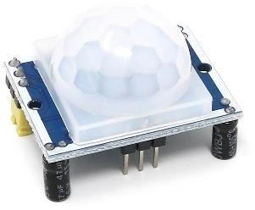

*Figure 5. PIR Motion*

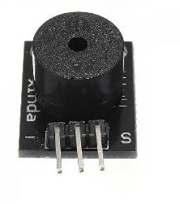

*Figure 6. Buzzer*

**Working:** The PIR sensor monitors movement. When motion is detected (such as an intruder), the Arduino activates a buzzer to alert occupants, enhancing home security.

### Module 4: Rain Water Detection and Clothes Protection

**Components**: Rain Sensor, Servo Motor

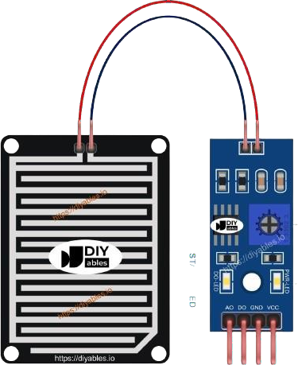

*Figure 7. Rain Sensor*



*Figure 8. Servo Motor SG-90*

**Working:** This module protects clothes drying outdoors. When the rain sensor detects water droplets, a servo motor pulls a cover over the clothes. When no rain is detected, the servo returns to its default position.

### Module 5: Soil Moisture and Water Tank Monitoring

**Components:** Soil Moisture Sensor, Ultrasonic Sensor, Water Pump, IRFZ44N MOSFET

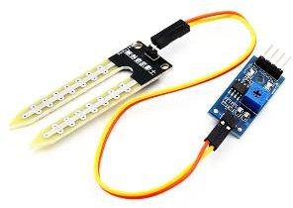

*Figure 9. Soil Moisture Sensor*

**

*Figure 10. HC-SR04 Ultrasonic Sensor*

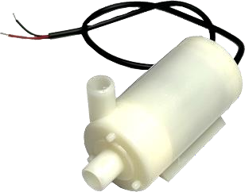

*Figure 11. Water Motor*

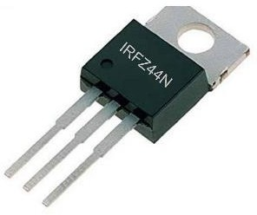

*Figure 12. IRFZ44N MOSFET*

**Working:** The soil sensor checks soil wetness while the ultrasonic sensor monitors water tank level. If the soil is dry and water is available, a pump is turned ON using a MOSFET switch to irrigate the field automatically.

### Module 6: Fire and Smoke Detection

**Components:** IR Flame Sensor, MQ2 Gas Sensor, LED and Buzzer

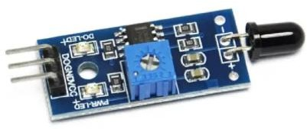

*Figure 13. Flame Sensor*

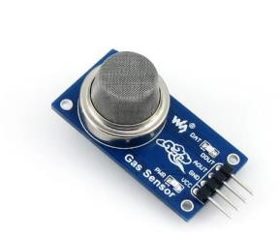

*Figure 14. MQ2 Gas Sensor*

**

*Figure 15. Buzzer*

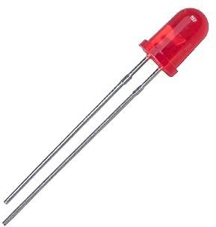

*Figure 16.LED*

**Working:** This safety module activates when flame or smoke is detected. If either is sensed, the Arduino turns on an alert LED and sounds a buzzer, warning people in the area.

### Module 7: Temperature and Humidity Monitoring

**Component:** DHT22 Sensor

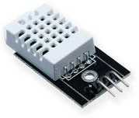

*Figure 17. DHT22 Sensor*

**Working:** This sensor continuously reads temperature and humidity levels and sends data to the Serial Monitor. It helps monitor environmental conditions and can be used for future automation like fans or greenhouses.

# 17.ARDUINO CODE

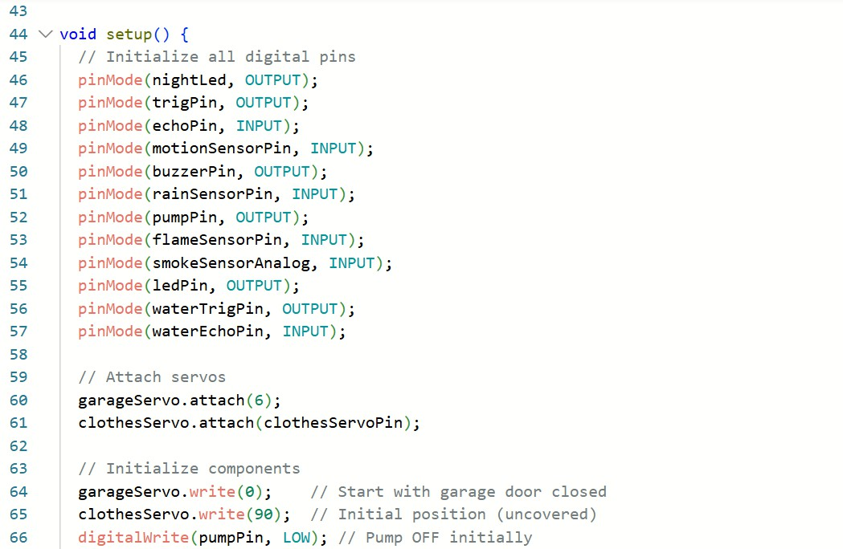

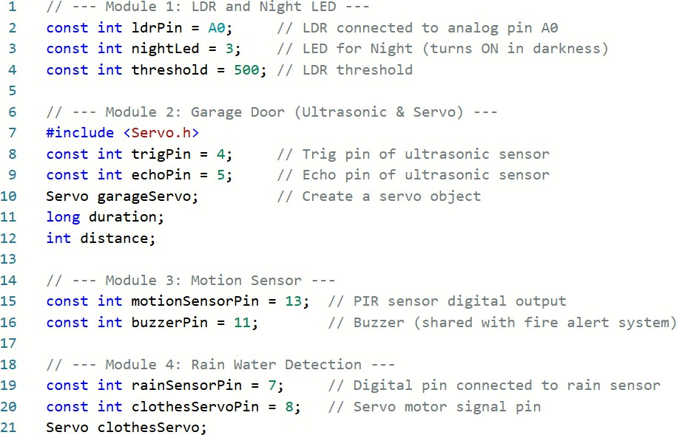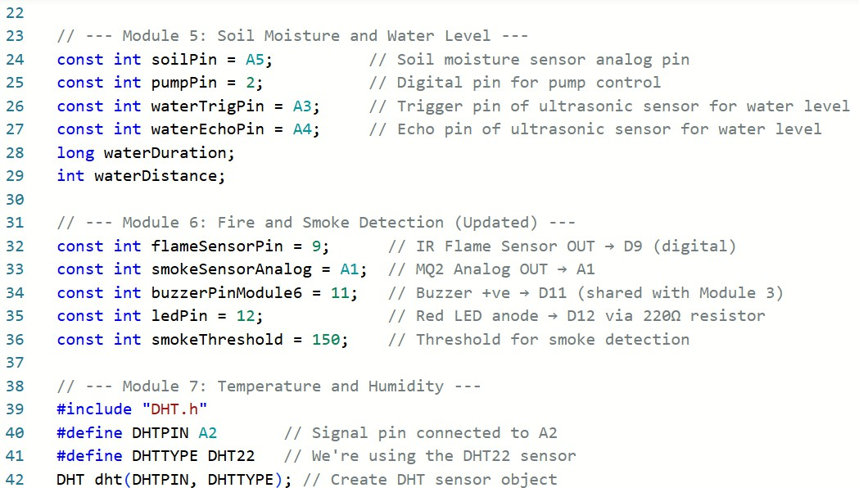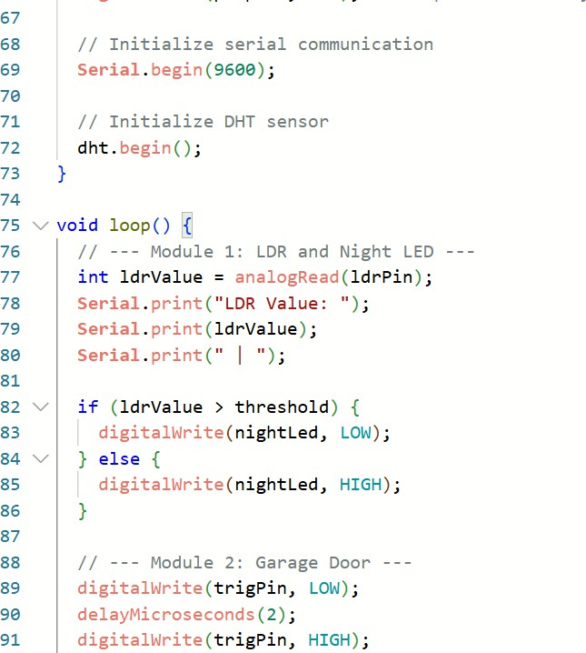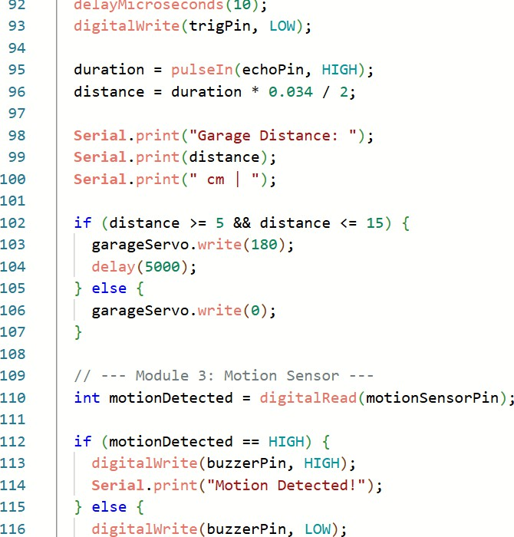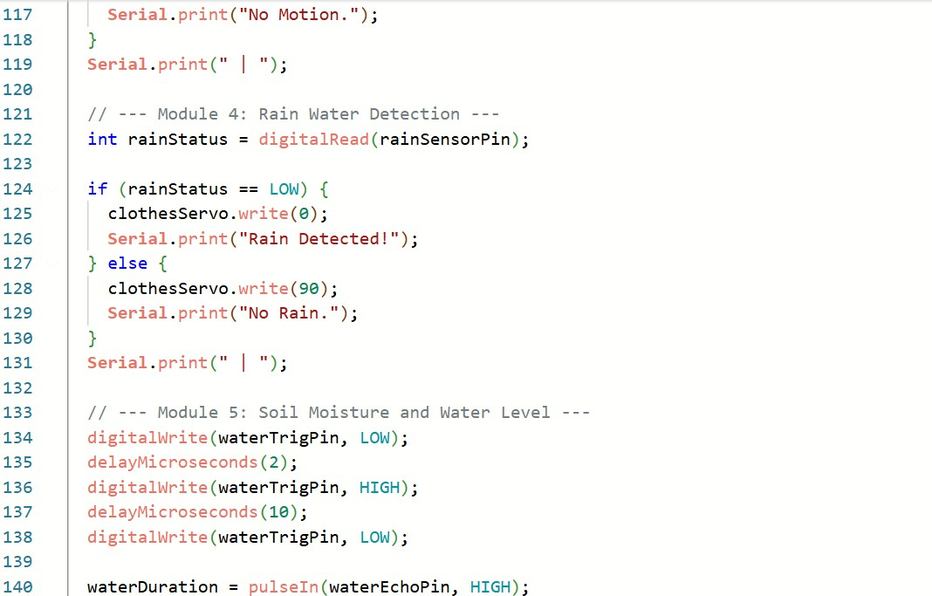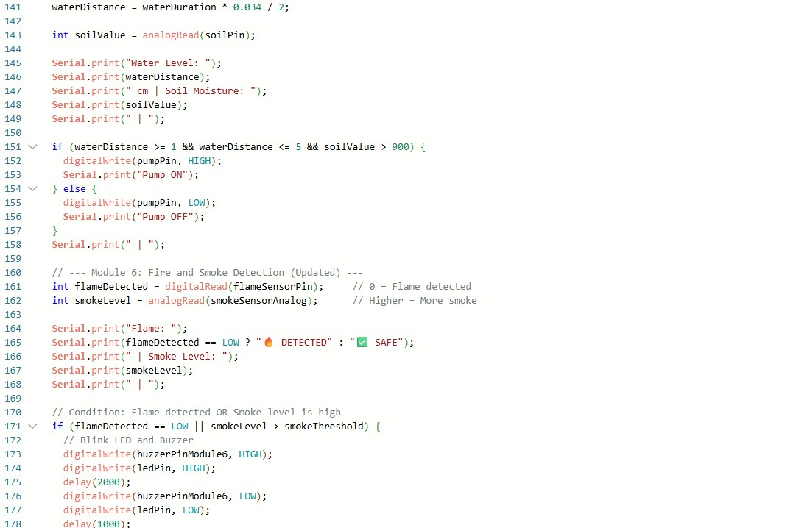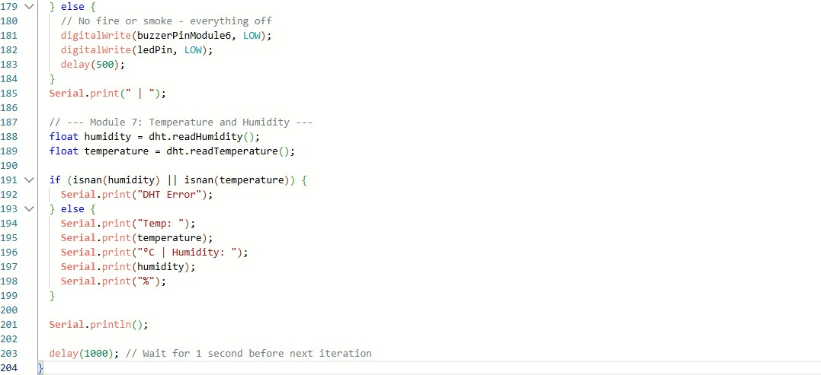

**Block Diagram of the Project :**

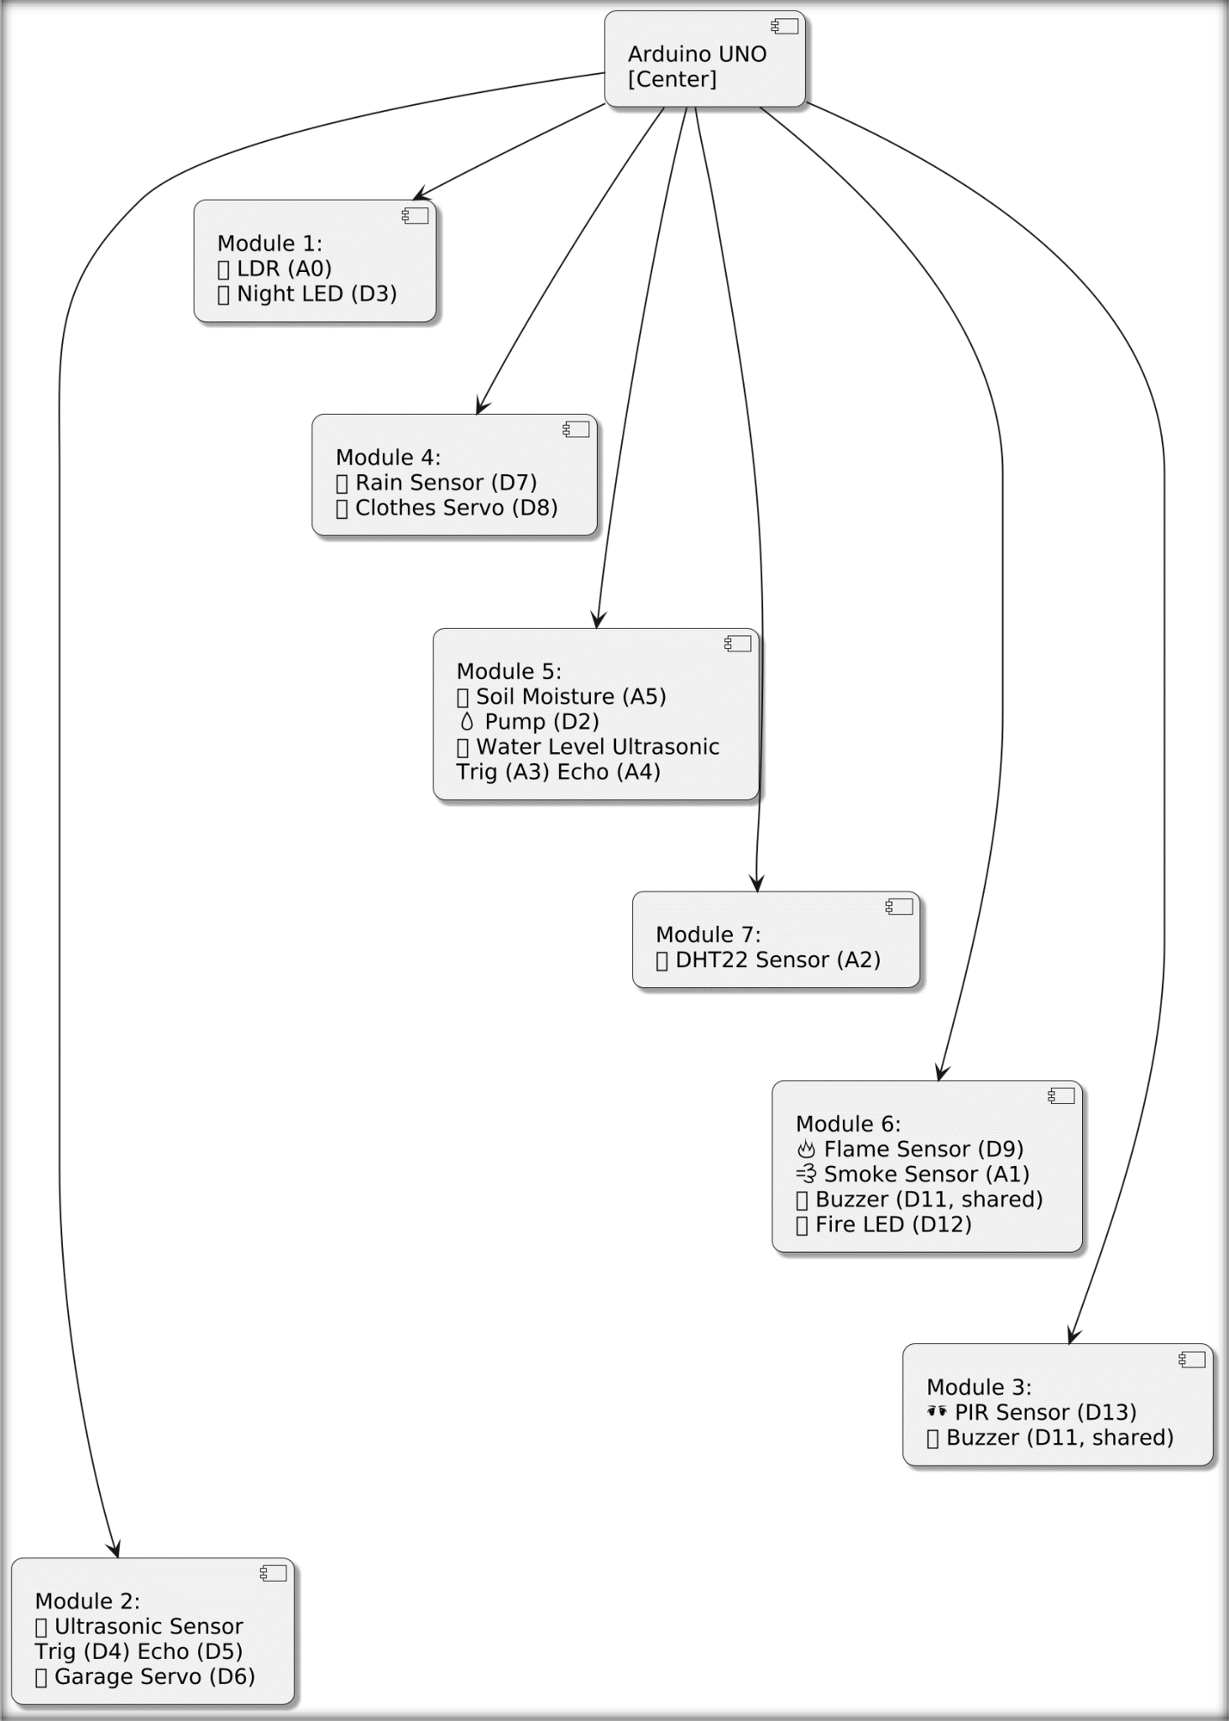

**Functionality:**

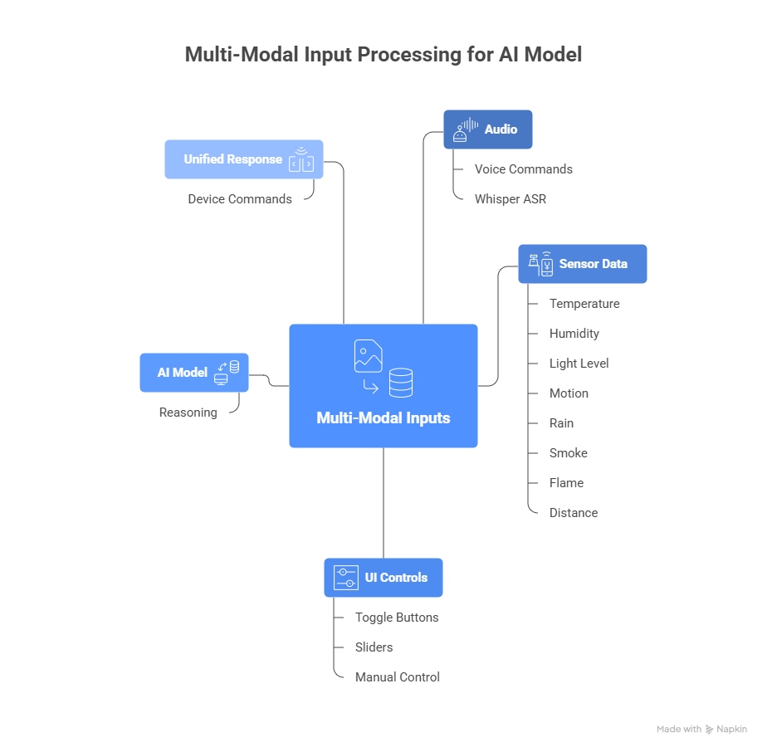

**Project Architecture :**

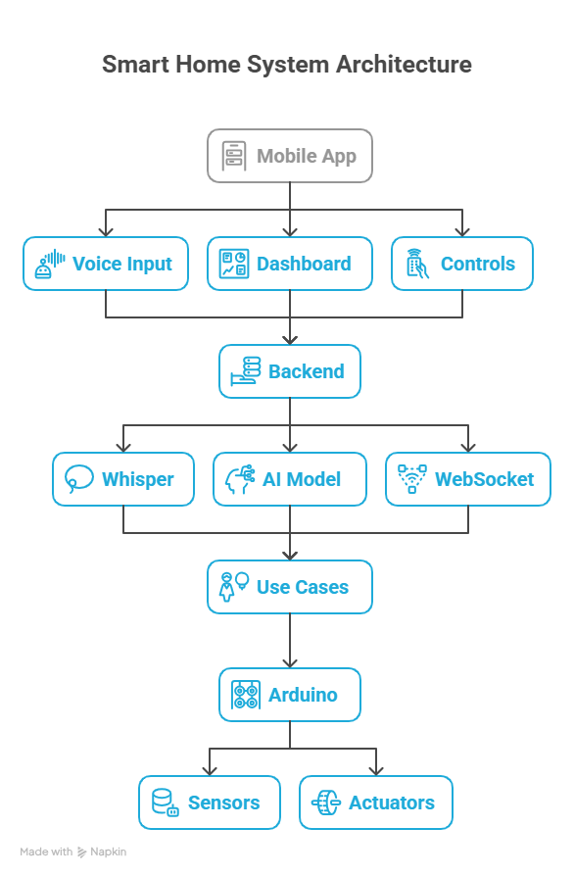

# Components:

Here's a complete list of **components with their module names**, indicating **which port or pin each component is connected to** in IoT project code:

##### Module 1: LDR and Night LED

|  |  |  |
| --- | --- | --- |
| **Component** | **Description** | **Connected to** |
| **LDR Sensor** | Light Dependent Resistor | A0 (Analog pin) |
| **Night LED** | LED turns ON in darkness | D3 (Digital pin) |
| **Threshold** | Value to detect darkness/light | Software only |

##### Module 2: Garage Door (Ultrasonic & Servo)

|  |  |  |
| --- | --- | --- |
| **Component** | **Description** | **Connected to** |
| **Ultrasonic Sensor** | Detects distance for garage  door | Trig: D4, Echo: D5 |
| **Garage Servo Motor** | Opens/closes garage door | D6 (Digital PWM pin via  garageServo.attach(6)) |

##### Module 3: Motion Sensor

|  |  |  |
| --- | --- | --- |
| **Component** | **Description** | **Connected to** |
| **PIR Motion Sensor** | Detects motion | D13 (Digital pin) |
| **Buzzer** | Sounds alarm on motion/fire | D11 (Shared with Module 6) |

##### Module 4: Rain Water Detection

|  |  |  |
| --- | --- | --- |
| **Component** | **Description** | **Connected to** |
| **Rain Sensor** | Detects rain | D7 (Digital pin) |
| **Clothes Servo** | Moves to cover/uncover  clothes | D8 (Digital PWM pin via  clothesServo.attach(8)) |

##### Module 5: Soil Moisture and Water Level

|  |  |  |
| --- | --- | --- |
| **Component** | **Description** | **Connected to** |

|  |  |  |
| --- | --- | --- |
| **Soil Moisture Sensor** | Detects soil wetness | A5 (Analog pin) |
| **Pump** | Waters plants | D2 (Digital pin) |
| **Water Level Sensor (Ultrasonic)** | Measures water tank  level | Trig: A3, Echo: A4 (Analog pins used  digitally) |

##### Module 6: Fire and Smoke Detection

|  |  |  |
| --- | --- | --- |
| **Component** | **Description** | **Connected to** |
| **IR Flame Sensor** | Detects fire/flames | D9 (Digital pin) |
| **MQ2 Smoke Sensor** | Detects smoke levels | A1 (Analog pin) |
| **Buzzer** | Sounds alarm for fire/smoke | D11 (Shared with Module 3) |
| **Red LED** | Visual alert for fire/smoke | D12 (Digital pin) |

##### Module 7: Temperature and Humidity

|  |  |  |
| --- | --- | --- |
| **Component** | **Description** | **Connected to** |
| **DHT22 Sensor** | Measures temperature & humidity | A2 (Digital use) |

##### Summary of Pin Mapping

|  |  |
| --- | --- |
| **Pin** | **Connected Component** |
| A0 | LDR Sensor |
| A1 | MQ2 Smoke Sensor |
| A2 | DHT22 Sensor |
| A3 | Water Level Sensor (Trigger) |
| A4 | Water Level Sensor (Echo) |
| A5 | Soil Moisture Sensor |
| D2 | Pump |
| D3 | Night LED |
| D4 | Ultrasonic Sensor (Garage - Trigger) |
| D5 | Ultrasonic Sensor (Garage - Echo) |
| D6 | Garage Door Servo Motor |
| D7 | Rain Sensor |
| D8 | Clothes Servo Motor |
| D9 | Flame Sensor |
| D11 | Buzzer (Shared for Motion + Fire Alert) |
| D12 | Fire Alert LED |
| D13 | PIR Motion Sensor |

# Protocols :

#### Module 1: LDR and Night LED

* **Protocol:** None (Analog Input / Digital Output)

###### Explanation:

The LDR is read as an analog voltage (using analogRead() on A0), and the LED is controlled by a digital pin (digitalWrite() on pin 3). No communication protocol is involved here, just basic analog and digital signals.

#### Module 2: Garage Door (Ultrasonic Sensor and Servo)

* **Protocol:** Pulse-based signaling + PWM

###### Explanation:

* + Ultrasonic sensor uses a **pulse timing** technique: a trigger pulse is sent (digitalWrite()), and the echo pulse duration is measured (pulseIn()), calculating distance based on the time of flight of the ultrasonic wave.
  + The servo is controlled via **PWM (Pulse Width Modulation)** signals generated by the Arduino servo library (Servo.attach() and Servo.write()).

#### Module 3: Motion Sensor (PIR) and Buzzer

* **Protocol:** Digital Input / Output

###### Explanation:

The PIR motion sensor outputs a digital HIGH or LOW signal detected on a digital input pin (digitalRead()), and the buzzer is turned on or off digitally (digitalWrite()). No advanced protocol is used.

223

#### Module 4: Rain Sensor and Servo

* **Protocol:** Digital Input / PWM Output

###### Explanation:

The rain sensor provides a digital signal indicating wet or dry (digitalRead()), and the clothes servo is controlled via PWM signals through the Servo library.

#### Module 5: Soil Moisture and Water Level (Ultrasonic Sensor and Pump)

###### Protocol:

* + Soil Moisture: Analog Input
  + Water Level Ultrasonic: Pulse Timing
  + Pump Control: Digital Output

###### Explanation:

* + Soil moisture sensor provides an analog voltage (analogRead()).
  + Water level ultrasonic sensor works the same way as Module 2 ultrasonic sensor using trigger and echo pulses.
  + Pump is turned on/off using digital output (digitalWrite()).

#### Module 6: Fire and Smoke Detection

###### Protocol:

* + Flame Sensor: Digital Input
  + Smoke Sensor (MQ2): Analog Input
  + Buzzer and LED: Digital Output

###### Explanation:

* + Flame sensor gives a digital HIGH or LOW signal depending on flame presence.
  + Smoke sensor provides an analog voltage level proportional to smoke concentration (analogRead()).
  + Buzzer and LED controlled digitally (digitalWrite()).

#### Module 7: Temperature and Humidity Sensor (DHT22)

###### Protocol: One-Wire / Single-Wire Digital Communication

* **Explanation:**

The DHT22 sensor uses a proprietary single-wire digital communication protocol to send temperature and humidity data to the Arduino. The DHT library handles the timing and data decoding over one digital pin (A2).

#### Summary Table of Protocols:

|  |  |  |
| --- | --- | --- |
| **Module** | **Sensors / Devices** | **Protocol / Communication Type** |
| 1 | LDR, LED | Analog Input, Digital Output |
| 2 | Ultrasonic sensor, Servo | Pulse timing, PWM |
| 3 | PIR sensor, Buzzer | Digital Input, Digital Output |
| 4 | Rain sensor, Servo | Digital Input, PWM |
| 5 | Soil moisture, Ultrasonic | Analog Input, Pulse timing, Digital Output |

|  |  |  |
| --- | --- | --- |
| 6 | Flame, Smoke sensors | Digital Input, Analog Input, Digital Output |
| 7 | DHT22 sensor | One-Wire digital protocol (single-wire communication) |

# 18.CONCLUSION

This Smart Home and Agriculture System demonstrates how affordable microcontrollers and basic sensors can automate real-life activities. The project effectively integrates environmental monitoring with responsive actions to create a safe, efficient, and smart environment for homes and farms.